# Emergency Plan

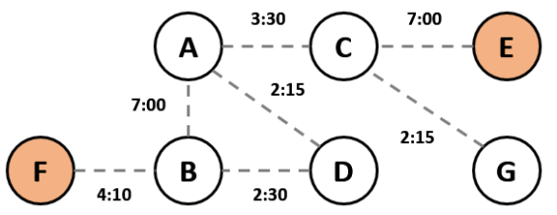

*Sample school building plan*

You are given a **building plan** of a school.

In the example above, we are given the time it takes to **go from one room to another** (e.g. from **A** to **B** it takes exactly **7 minutes**).

All students must evacuate in time **T = 9** **minutes**. The **red circles** denote **exits**. Assume that the **students know the quickest way** to an exit and will always take it. We find quickest exit routes for each room:

|  |  |  |  |  |  |
| --- | --- | --- | --- | --- | --- |
| **Room** | **A** | **B** | **C** | **D** | **G** |
| **Time to Exit** | **8:55** | **4:10** | **7:00** | **6:40** | **9:15** |

**Room G** cannot be evacuated in **time T = 9** minutes**.** Therefore, the room is not safe.

## Input

* On the first input line the **number of rooms** **N** will be given. Rooms will be numbered from **0** to **N-1**.
* On the second input line the the **exit rooms** will be given in the format "**E1 E2 … En**".
* On the third input line the **number of connections C** between rooms will be given.
* On the next **C** lines connections will be given in the format "**RA RB T**", denoting the time it takes to go from **room A** to **room B** (applies for both directions).
* On the last line you will be given the **time** **T** in which all rooms must be evacuated.

## Output

* For each room (starting from 0) print one of the following:
  + If the room can be evacuated: "Safe {room} ({best time to nearest exit})".
  + If the room cannot be evacuated: "Unsafe {room} ({best time to nearest exit})".
  + If a room has no access to an exit: "Unreachable {room} (N/A)".
  + All output times should be printed in the format "**hh:mm:ss**".

## Constraints

* All input times will be given in the format "**mm:ss**". They will be in the range [00:01…59:59].
* The number of **rooms N** will be an integer number in the range [1…100].
* Output times will not exceed **23:59:59**.
* The number of **exits E** will be an integer number in the range [1…100]

## Examples

|  |  |  |
| --- | --- | --- |
| **Input** | **Output** | **Visual** |
| 7  5 4  7  1 5 04:10  2 4 07:00  6 2 02:15  0 3 02:15  1 0 07:00  1 3 02:30  2 0 03:30  09:00 | Safe 0 (00:08:55)  Safe 1 (00:04:10  Safe 2 (00:07:00)  Safe 3 (00:06:40)  Unsafe 6 (00:09:15) |  |
| 5  4  5  1 2 02:30  2 3 07:30  1 3 02:15  1 4 04:30  4 3 01:15  04:00 | Unreachable 0 (N/A)  Safe 1 (00:03:30)  Unsafe 2 (00:06:00)  Safe 3 (00:01:15) |  |